Bahria University,

Karachi Campus



LAB EXPERIMENT NO. _02_

LIST OF TASKS

|  |  |
| --- | --- |
| TASK NO | OBJECTIVE |
| Task 1 | Create an array of length 10 of integers. Values ranging from 1 to 50.   * 1. Find all pair of elements whose sum is 25.   2. Find the number of elements of A which are even, and the number of elements of A which are odd.   3. Write a procedure which finds the average of the value of A.   4. Write a procedure which adds an element in an array at a given index. Take the value to add and the index from the user.   5. Write a procedure which looks for 2 numbers 45 and 14 in an array and delete them if they are present in the array. |
| Task 2 | Create a 2 dimensional Array. Translate the matrix multiplication algorithm into a program which finds the product C of an *nxm* matrix A and *pxn* matrix B. |
| Task 3 | N/A |
| Task 4 | N/A |
| Task 5 | N/A |
| Task 6 | N/A |
| Task 7 | N/A |
| Task 8 | N/A |

Submitted On:

__20/02/2020__

(Date: DD/MM

**Task No. 1:** Create an array of length 10 of integers. Values ranging from 1 to 50.

1. Find all pair of elements whose sum is 25.
2. Find the number of elements of A which are even, and the number of elements of A which are odd.
3. Write a procedure which finds the average of the value of A.
4. Write a procedure which adds an element in an array at a given index. Take the value to add and the index from the user.

Write a procedure which looks for 2 numbers 45 and 14 in an array and delete them if they are present in the array.

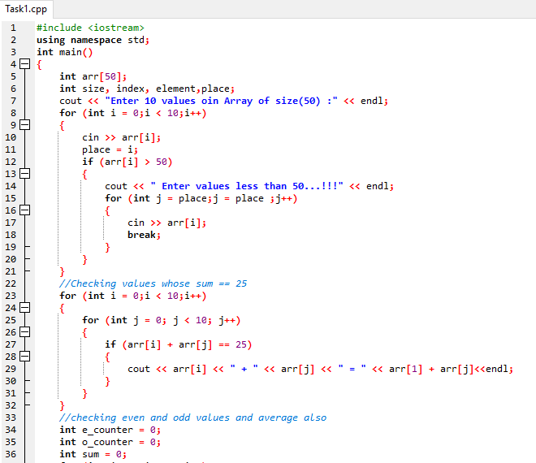**Coding:**

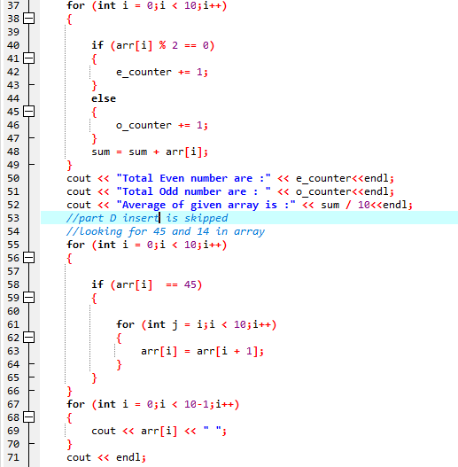 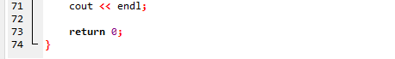

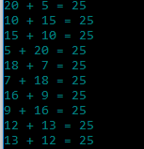**Output:**

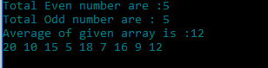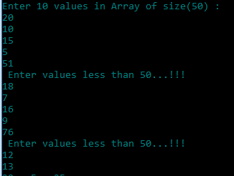

**Task No. 2:** Create a 2 dimensional Array. Translate the matrix multiplication algorithm into a program which finds the product C of an *nxm* matrix A and *pxn* matrix B.

**Coding:**

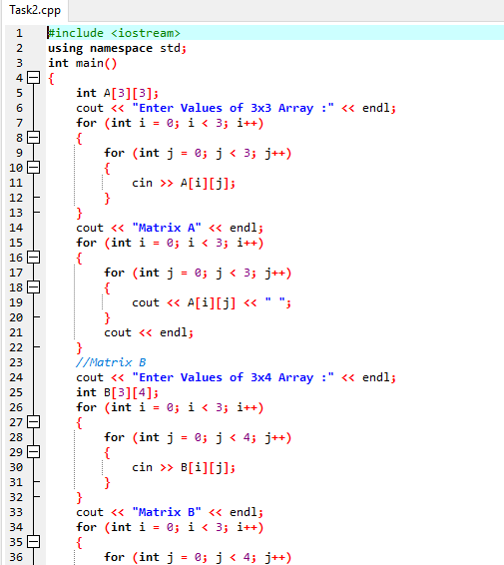

**Output:**

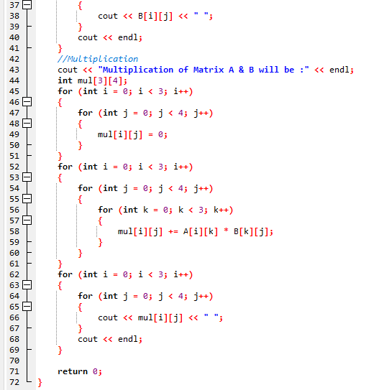



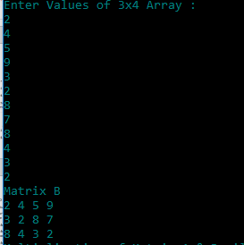**Output:**

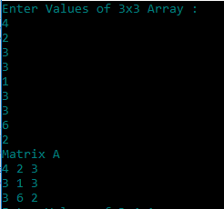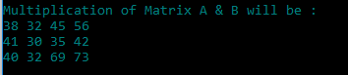

**Task No. 3:**

**Coding:**